**Event information**

**Hunters Bog Trotters Petlands junior hill races**

**Date:** Sunday 25th September

**Entries:** Email advance entry only. No late entries or entry on the day.

Email: [Meganmowbray@doctors.org.uk](mailto:Meganmowbray@doctors.org.uk).

Please list the following:

Name

DOB

Age on race day

Club

Email contact

Race category you want to enter

**Entries Open:** Monday 5th September.

**Entries Close:**Friday 23rd September 12noon.

**Cost of Entry:**£1 (bring cash on the day).

**U13 race:** **Boys and** **Girls 12.20**

Distance 3.2km; Climb 110m. Born 2010 or 2011.

**U15 race:** **Boys and Girls 13.00**

Distance 4.9km; Climb 212m. Born 2008 or 2009.

**U17 and U20 race:** **Boys and Girls 13.40**

Distance 7.4km; Climb 326m. U17 born 2006 to 2007, U20 born 2003 to 2005. Boys and Girls races may be combined if entries allow, with any such combined race going at 13.40pm.

**Parking, changing**

Please travel to the event using public transport if possible. Parking is available at the Bonaly car park. EH13 0PB There will be no changing room/shower facilities. Please arrive ready to race. The walk from the bottom Bonaly car park to the start is 1km uphill, allow 20-30minutes.

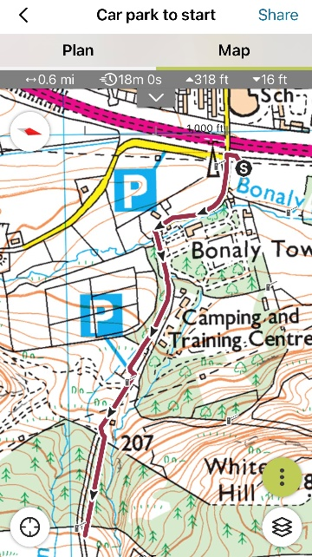

**Race numbers**

Race numbers will be provided at registration. Please bring your own safety pins and pin your number at each corner.

**Terrain**

The course is off road on paths of mud and grass.

**Safety**

The course will be clearly marked and marshalled. A sweeper will run each race. There will also be a first aid presence. Be familiar with the SHR safety rules.

**You MUST bring a waterproof top and whistle and carry these during the race**even if the weather is fair**.** Checks will be carried out on the start line. This is a **compulsory**race condition**. No top/whistle = no run.**NB if you start but then pull out, you MUST report to a race marshal or to the finish team (without running through the finish).

Please check yourself for ticks after the event.

**Other park users**

Please respect other park users.  Please avoid disturbance to sheep. Sheep graze the moorland all year round, if you come across sheep, please give them a wide berth and do not run through the middle of the flock as this will cause stress.

**Results**

There will be no race results available on the day. Race results will be posted online by Monday 26th September.

**Covid-19**

We would ask you to note and comply with the following:

Please do not attend if you are ill, have symptoms of Covid-19.

Bring your own food and drink for pre-race and post-race. No post-race water or snack will be provided.

**Entry terms**

In submitting an entry all entrants acknowledge that this is an off-road hill race on rough steep terrain with inherent risk.

They confirm that they will comply with the instructions of the race officials and marshals including the content of the Race Information Sheet.

They will report to a race official if they start but do not finish.

They will make themselves familiar with the SHR Safety Rules and Guidelines  available at <https://www.scottishhillrunners.uk/Safety.aspx> .

**Maps of race routes**

**U13 boys/girls**

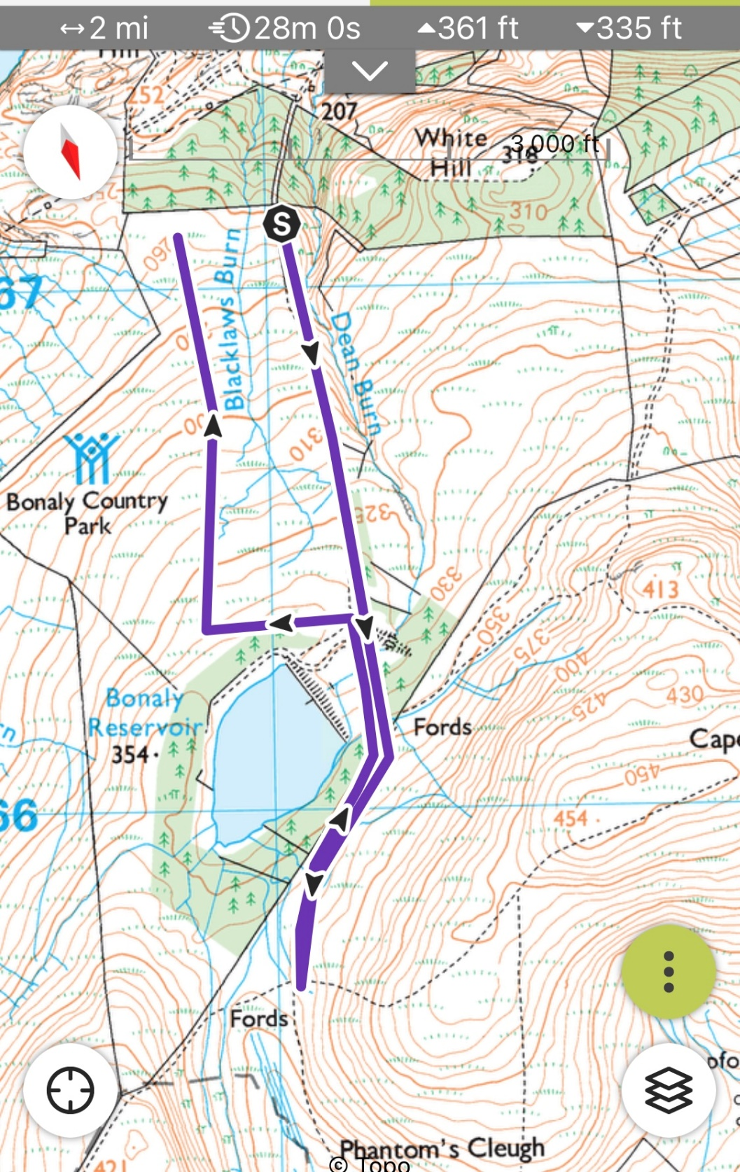

**U15 Boys and Girls**

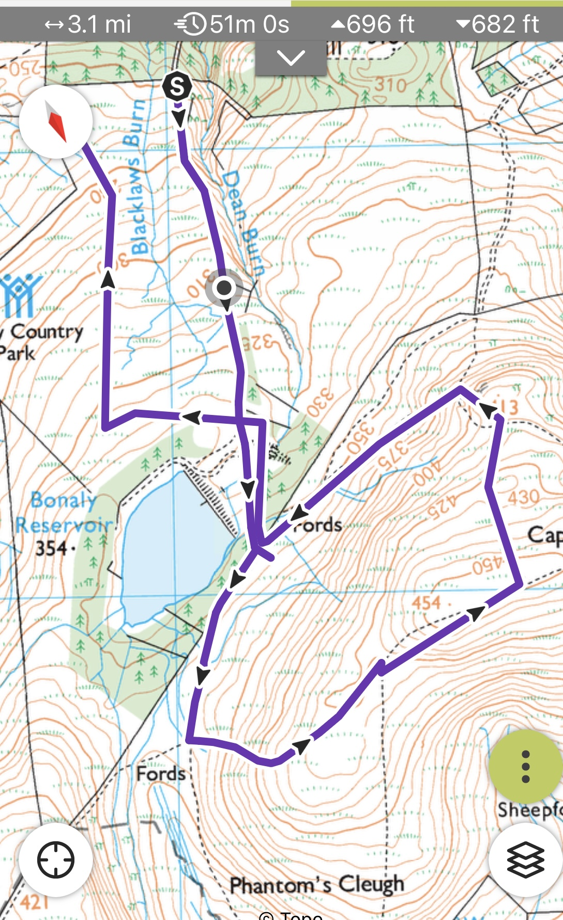

**U17 and U20 boys and girls**

**Two laps of the hill loop**



2 laps of hill loop